**COVID 19- LABOURS HELPLINE**

**INTRODUCTION**

* 1. **Introduction to Project**

Covid-19 pandemic is sweeping through India at a pace that has staggered scientists. Daily case numbers have exploded since early March 2020 and is increasing exponentially. This pandemic has affected the lives of many people in different ways. In countries like India with huge population, it is very difficult for the governments to provide all required amenities for the people.

During these difficult times it is very necessary to stretch out hands for the poor people like labours who work for daily wages to provide them with basic needs like food, clothes, help them to reach their places during these lockdown situations etc. In this project we have made an attempt to use the technology to connect those people with volunteers who can help them with their requirements.

* 1. **Purpose of the Project**

This is totally online system.

1. The system has features like, the requesters can post their help based on the needs, individuals can register as volunteers who are ready to stretch out for those in need.
2. The system is very user friendly, and users can post help request very easily just with a click.
3. Currently the system allows to request for basic amenities like, request for food, clothes, and the people who are unable to reach their family or homes can post for travel request.
4. The system has a monitoring admin dashboard which can connect the peoples request to the volunteers.

**Module 1: Project Overview**

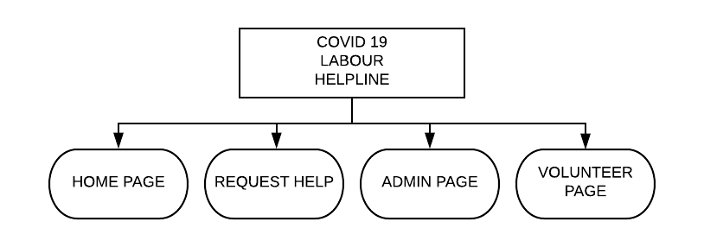

**Module 2:Home Page Contents**

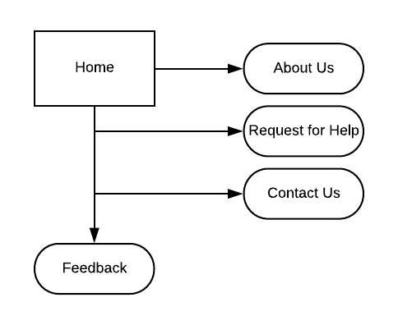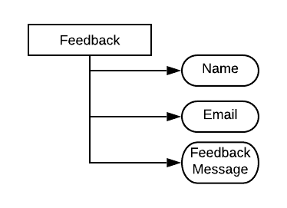

**Module 3: Registration & Login Page**

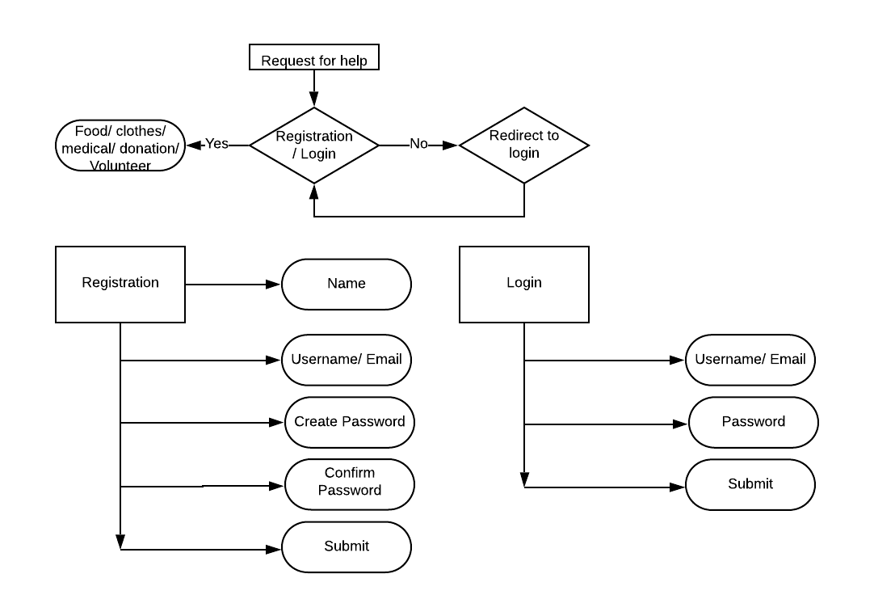

**Module 4: Request For Help Page**

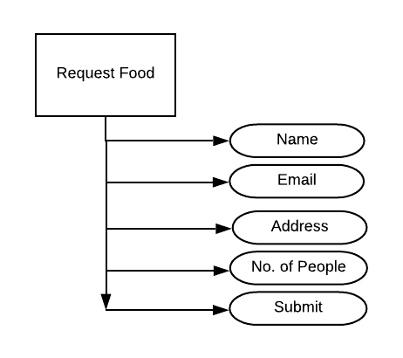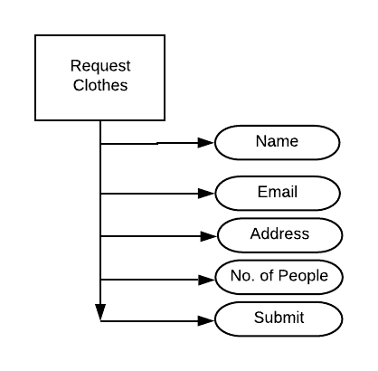

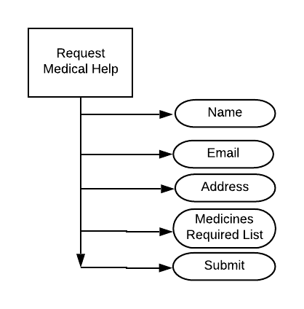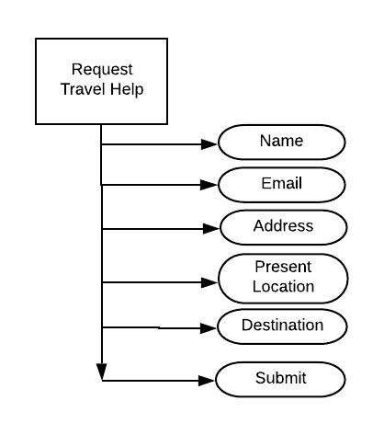

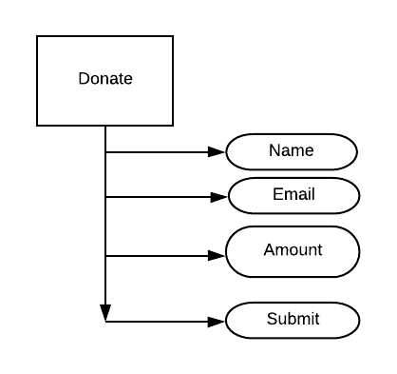

**Module 5: Become Volunteer Page**

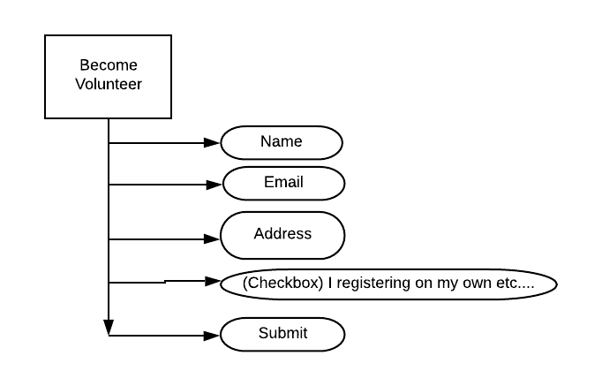

**Module 6: Admin Page**

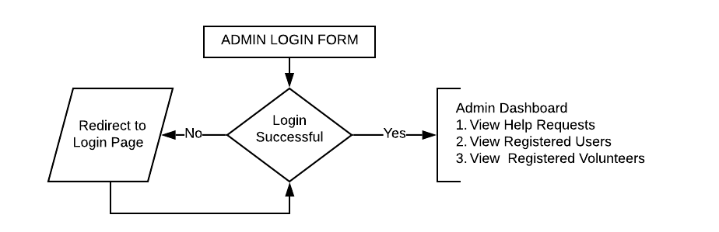

**FORMS:**

**Registration Form**

|  |  |
| --- | --- |
| **Name** |  |
| **Email** |  |
| **Password** |  |

**Submit**

**Login Form**

|  |  |
| --- | --- |
| **Name** |  |
| **Email** | **Submit** |

**Feedback Form**

|  |  |
| --- | --- |
| **Name** |  |
| **Email** |  |
| **Message** |  |

**Submit**

**RequestFoodForm**

|  |  |
| --- | --- |
| **Name** |  |
| **Email** |  |
| **Address**  **No. Of People** |  |

**Submit**

**RequestClothesForm**

|  |  |
| --- | --- |
| **Name** |  |
| **Email** |  |
| **Address**  **No. Of People** |  |

**Submit**

**Medical Form**

|  |  |
| --- | --- |
| **Email** |  |
| **Address** |  |
| **Medicine** |  |

**Submit**

**Travel Help Form**

**Email ID**

**Present Address**

**Destination Address**

**C:\Users\UDAYNA~1\AppData\Local\Temp\ksohtml8656\wps1.png**

**Donate Form**

**Name**

**Email ID**

**Amount**

**C:\Users\UDAYNA~1\AppData\Local\Temp\ksohtml8656\wps1.png**

**Volunteer Form**

|  |  |
| --- | --- |
| **Name** |  |
| **Email** |  |
| **Address** |  |

**Submit**